Instructions for creating the MySQL database

1. Download MySQL installer from the link below:  
   <https://dev.mysql.com/downloads/windows/installer/8.0.html>  
   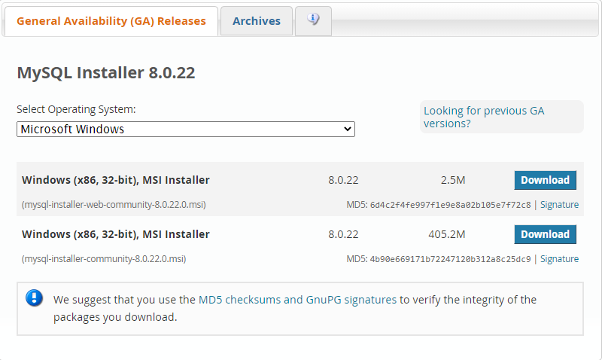
2. Use the first download in the web page
3. Run the download
4. Select custom install.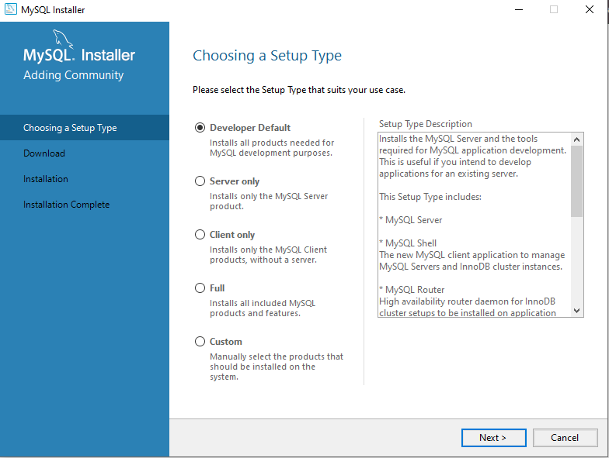
5. Select the following on the screen below  
   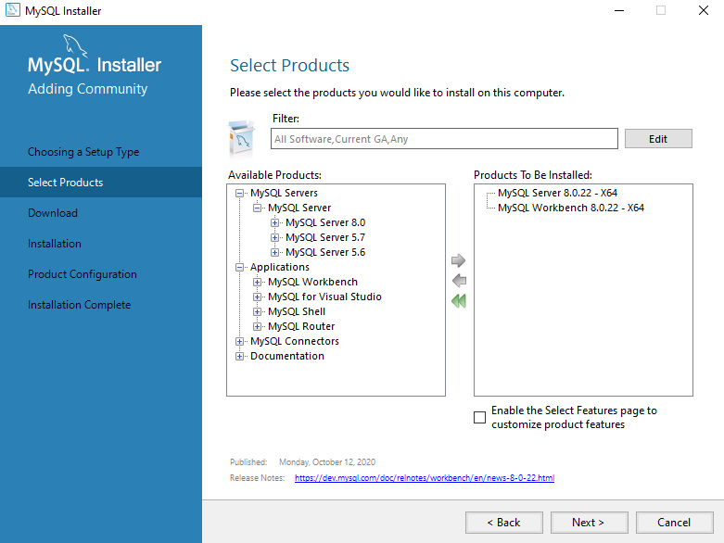
6. Execute the downloads.
7. Execute the installations.
8. Click finish once installs are done
9. MySQL Workbench should open and we can start the next phase

Configure MySQL Server

1. If configuration for MySQL Server does not appear on screen, open MySQL installer and click “reconfigure” on the MySQL server  
   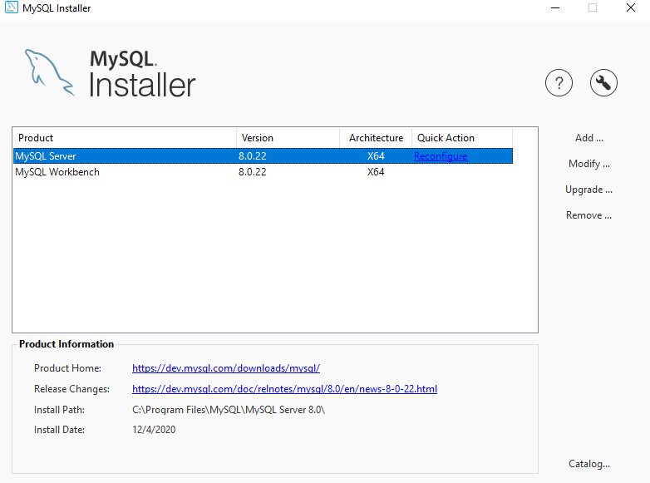
2. Select next on the next screen shown below  
   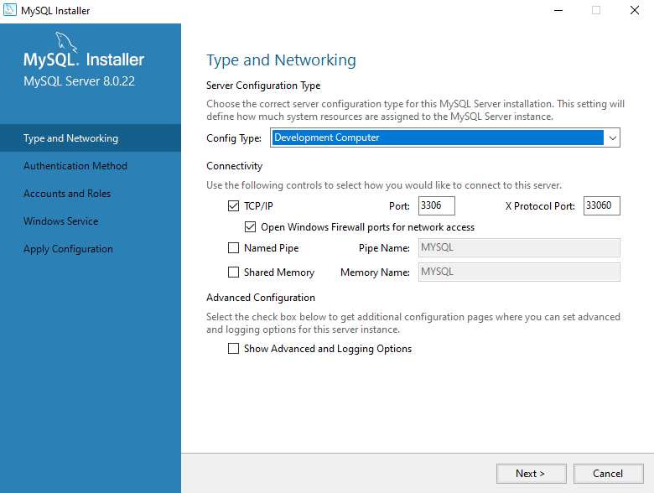
3. Click next again
4. Enter a password of your choice to the MySQL root user, then add a new user called “Manager” with password “password”  
   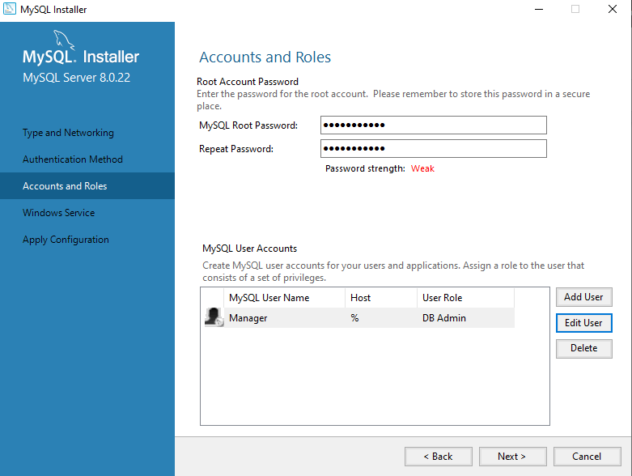
5. Note the service name of MySQL80 and click next. This is how you will stop and start the server in Windows Services
6. Execute configuration.

Prepare the MySQL Schema

1. Using the MySQL Workbench, double click on the connection to our serve. Default name is Local Instance MySQL80
2. Enter your root password  
   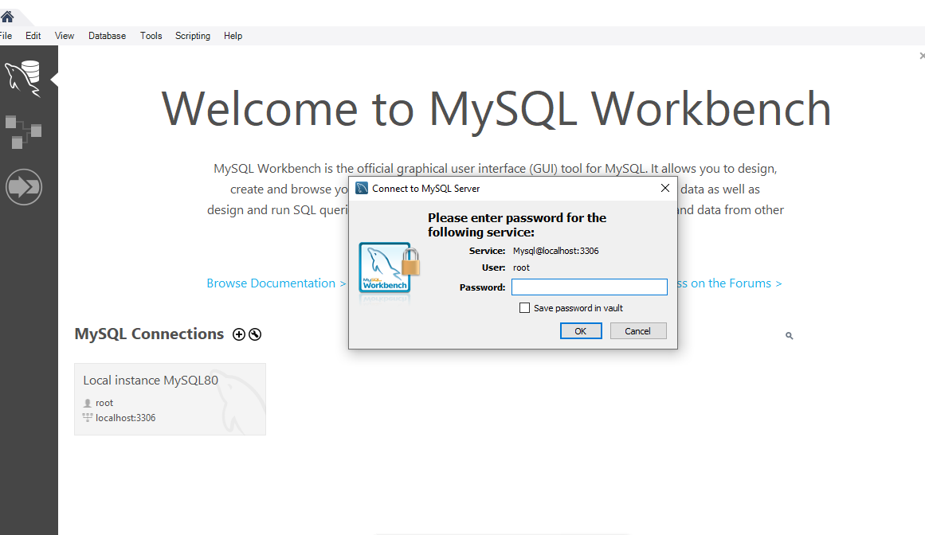
3. Select “Server” from the top bar, then select “Data Import”  
    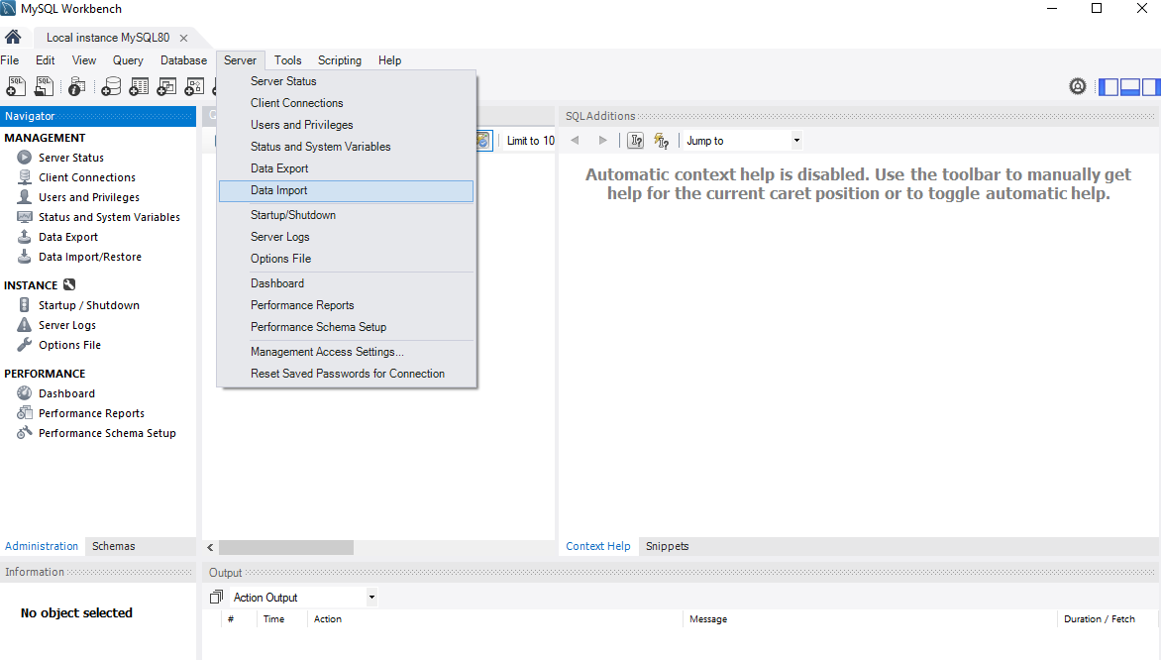
4. Use the provided database dump folder named “CheckInTechDump_Blank” under “MySQL” to initialize your database tables. Click “Load Folder Contents”, then click “Start Import”. Also ensure that the drop down says “Dump Structure and Data”.
   1. Note: “CheckInTechDump_Example” folder contains a partially filled out database.

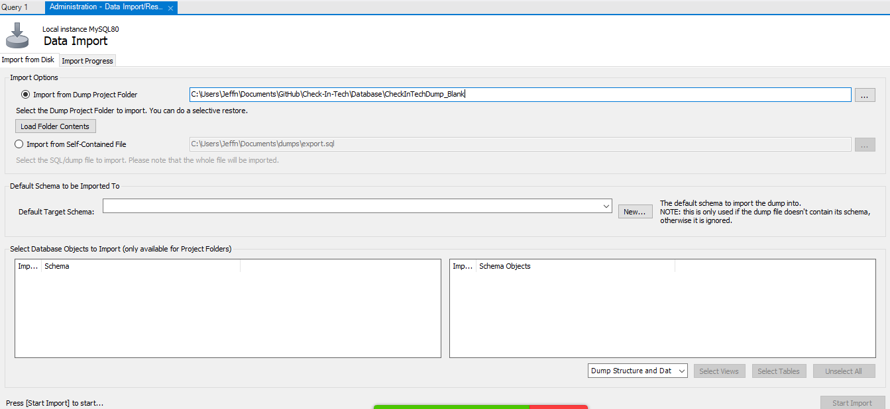  
Below is the finished import screen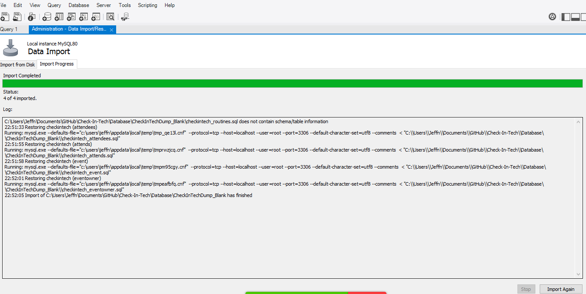

1. Refresh the MySQL Schemas window and the CheckInTech tables should be populated  
   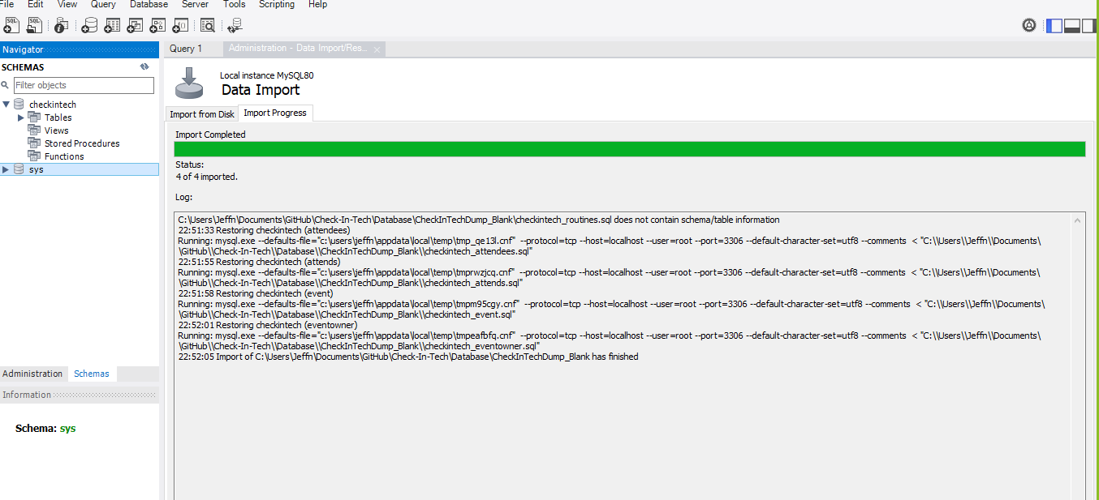  
   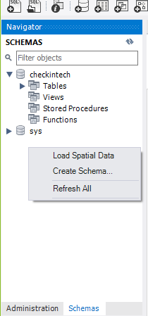
2. Create stored procedures from the sql files in the stored procedures folder. This is done by clicking the blue folder icon, then opening a stored procedure, then clicking apply at the bottom left. This is repeated per stored procedure.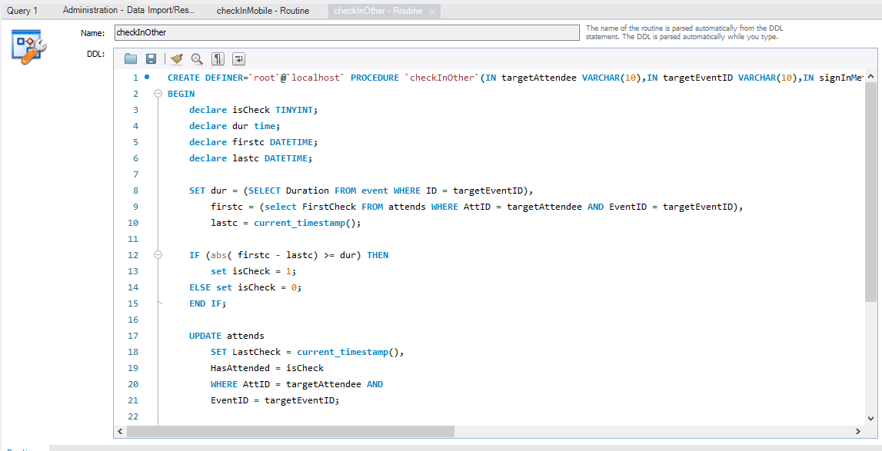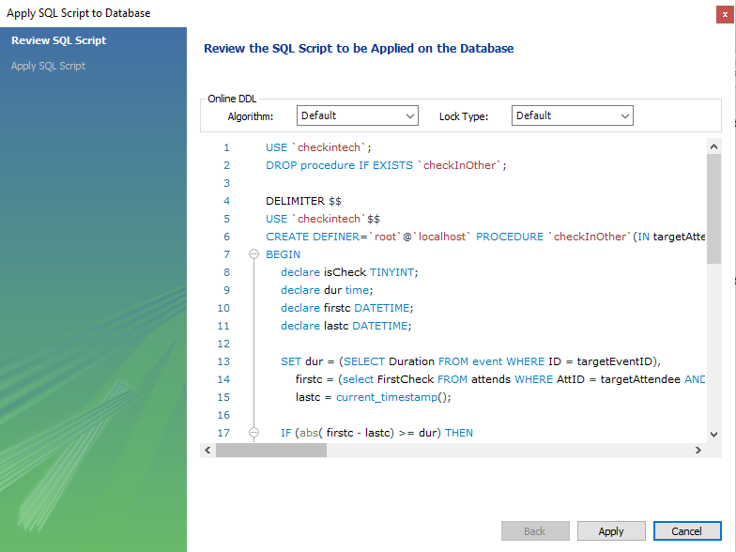
3. Your Schema should now look as follows. If so, you have completed the MySQL server setup and can now run the main application. Note that if you use the blank import, the default login for the Check N Tech application is:
   1. User: “Default”
   2. Password: “Default”

